Act as an experienced certified nutrition coach, healthy meal planner, and productivity-focused lifestyle advisor for busy working professionals.

Your task is to create a world-class, detailed 7-day healthy meal plan for South Indian working professionals who have busy schedules, limited cooking time, and want balanced meals for energy, focus, and overall wellness.

Context:
The meal plan should be practical for office-going Indian professionals. Meals should be easy to prepare, affordable, nutritious, and suitable for people who may not have much time in the morning.
Include:
- Breakfast
- Mid-morning snack
- Lunch
- Evening snack
- Dinner
- Hydration suggestion
- Overall calorie details
- Why the day is healthy
The plan should focus on balanced nutrition, including:
- Protein
- Fibre
- Healthy fats
- Vegetables
- Whole grains
- Practical South Indian food options
Avoid:
- Extreme dieting
- Crash diets
- Skipping meals
- Overly restrictive food rules
- Very low-calorie plans

Few-shot example of the expected style:
Example row:
Day: Monday
Breakfast [7:30 AM]: Oats with banana, chia seeds, and nuts Kcal: 350–420
Mid-Morning Snack [10:30 AM]: Greek yogurt or fruit Kcal: 150–180
Lunch [1:00 PM]: Brown rice with grilled chicken/tofu, vegetables, and dal Kcal: 550–650
Evening Snack [4:30 PM]: Roasted chana or nuts Kcal: 180–220
Dinner [7:30 PM]: Vegetable soup with whole wheat toast and boiled egg/paneer Kcal: 450–550
Hydration Suggestion [8:00 AM–8:00 PM]: 2–3 litres of water across the day Overall Calorie Details: Approx. 1,680–2,020 kcal/day

Why This Day Is Healthy: Balanced carbs, protein, vegetables, and healthy fats support energy, focus, digestion, and fullness.

Now generate the full response in a clear, professional, readable table format with the following columns:
- Day
- Breakfast [7:30 AM]
- Mid-Morning Snack [10:30 AM]
- Lunch [1:00 PM]
- Evening Snack [4:30 PM]
- Dinner [7:30 PM]
- Hydration Suggestion [8:00 AM–8:00 PM]
- Overall Calorie Details
- Why This Day Is Healthy

Formatting instruction:
For every meal cell, write the food first and show the calorie details on the next line.
Example:
2 idli + sambar + small coconut chutney. Veg: paneer cubes. Non-veg: 1 boiled egg.
Kcal: 350–420

Response requirements:
- Create a complete 7-day meal plan from Monday to Sunday.
- Keep the meals healthy, practical, affordable, and easy for working professionals.
- Include vegetarian and non-vegetarian alternatives wherever possible.
- Use simple, beginner-friendly language.
- Include calorie details in brackets or on the next line for every meal.
- Include overall daily calorie range for each day.
- Make the plan balanced, realistic, and sustainable.
- Add 5 simple rules to follow during the week in a small table.
- Mention that people with medical conditions, allergies, or special dietary needs should consult a qualified healthcare professional.
- Make it more professional and easier to understand
- Add appropriate icons wherever possible.

ChatGPT

Day | Breakfast  [7:30 AM] | Mid-Morning Snack  [10:30 AM] | Lunch  [1:00 PM] | Evening Snack [4:30 PM] | Dinner  [7:30 PM] | Hydration Suggestion  [8:00 AM–8:00 PM] | Overall Calorie Details  (Approx Kcal/day) | Why This Day Is Healthy
Monday | 2 idli + sambar + small coconut chutney. Veg: paneer cubes. Non-veg: 1 boiled egg.  Kcal: 350–420 | 1 banana/apple + 5 almonds.  Kcal: 150–180 | Brown rice + sambar + carrot/cabbage poriyal + curd. Non-veg: grilled chicken/fish.  Kcal: 550–650 | Sundal or roasted chana.  Kcal: 180–220 | 2 chapati + vegetable kurma + dal / egg bhurji.  Kcal: 450–550 | 2–3 litres water; buttermilk after lunch if needed. | 1,680–2,020 | Balanced carbs, protein, vegetables, and curd. Good for Monday work energy and digestion.
Tuesday | Vegetable upma with peanuts + curd. Non-veg: 1 boiled egg.  Kcal: 380–450 | Papaya or guava.  Kcal: 100–140 | Lemon brown rice + cucumber raita + chana salad. Non-veg: chicken tikka pieces.  Kcal: 550–650 | Green tea + makhana / peanuts.  Kcal: 150–220 | Dosa + sambar + tomato chutney. Veg: paneer/tofu filling.  Kcal: 450–550 | Sip water every 1–2 hours; avoid sugary drinks. | 1,630–2,010 | Chana, peanuts, curd, and sambar provide protein and fibre. Meals are simple and office-friendly.
Wednesday | Ragi dosa + peanut chutney / ragi malt with less sugar. Add egg/paneer if needed.  Kcal: 350–430 | Curd / Greek yogurt + fruit.  Kcal: 160–220 | Curd rice using brown rice + beetroot poriyal + dal. Non-veg: omelette or fish with less oil.  Kcal: 550–650 | Sprouts salad with lemon.  Kcal: 150–200 | Vegetable kichadi with moong dal + salad.  Kcal: 420–520 | 2–3 litres water; drink plain water before tea/coffee. | 1,630–2,020 | Ragi, dal, sprouts, curd, and vegetables support fullness, digestion, and steady energy.
Thursday | Ven pongal with moong dal + sambar. Use less ghee.  Kcal: 400–500 | Orange/apple + 4 walnuts.  Kcal: 150–200 | 2 chapati + mixed vegetable curry + dal. Non-veg: chicken curry with less oil.  Kcal: 550–650 | Buttermilk + roasted peanuts.  Kcal: 180–230 | Idiyappam + vegetable stew. Add egg/paneer/tofu.  Kcal: 450–550 | 1 glass water before lunch and dinner; total 2–3 litres. | 1,730–2,130 | Protein from dal, egg, paneer, or tofu helps reduce evening tiredness. Vegetables add fibre and nutrients.
Friday | Adai dosa with chutney or avial. Non-veg: boiled egg separately.  Kcal: 420–520 | Fruit bowl.  Kcal: 120–180 | Tomato brown rice + cucumber salad + curd + dal. Non-veg: grilled fish/chicken.  Kcal: 550–650 | Boiled corn / sundal.  Kcal: 160–220 | 2 chapati + palak paneer / tofu / egg curry.  Kcal: 480–580 | 2–3 litres water; reduce sweet tea/coffee. | 1,730–2,150 | Adai is protein-rich. Spinach, dal, curd, and vegetables make the day nutrient-dense.
Saturday | Oats idli / oats kanji + sambar.  Kcal: 350–430 | Banana + small spoon peanut butter / nuts.  Kcal: 180–250 | South Indian meal: small rice portion + sambar + rasam + 2 vegetables + curd. Non-veg: fish/chicken curry with less oil.  Kcal: 650–750 | Tea/coffee with less sugar + roasted chana.  Kcal: 150–220 | Vegetable dosa roll with paneer/tofu/egg filling.  Kcal: 450–550 | 8–10 glasses water across the day. | 1,780–2,200 | Keeps traditional weekend food while maintaining portion control, protein, vegetables, and fibre.
Sunday | Appam / dosa + vegetable stew. Add egg/paneer/tofu.  Kcal: 450–550 | Watermelon or seasonal fruit.  Kcal: 100–150 | Millet biryani / brown rice biryani with vegetables. Non-veg: chicken/fish biryani with less oil + raita.  Kcal: 650–800 | Nuts + fruit or sundal.  Kcal: 180–250 | Light dinner: rasam rice with vegetables / soup + chapati + dal.  Kcal: 400–500 | 2–3 litres water; avoid soft drinks as water replacement. | 1,780–2,250 | Enjoyable Sunday meals with balanced carbs, protein, vegetables, curd, and a lighter dinner.
ChatGPT Image
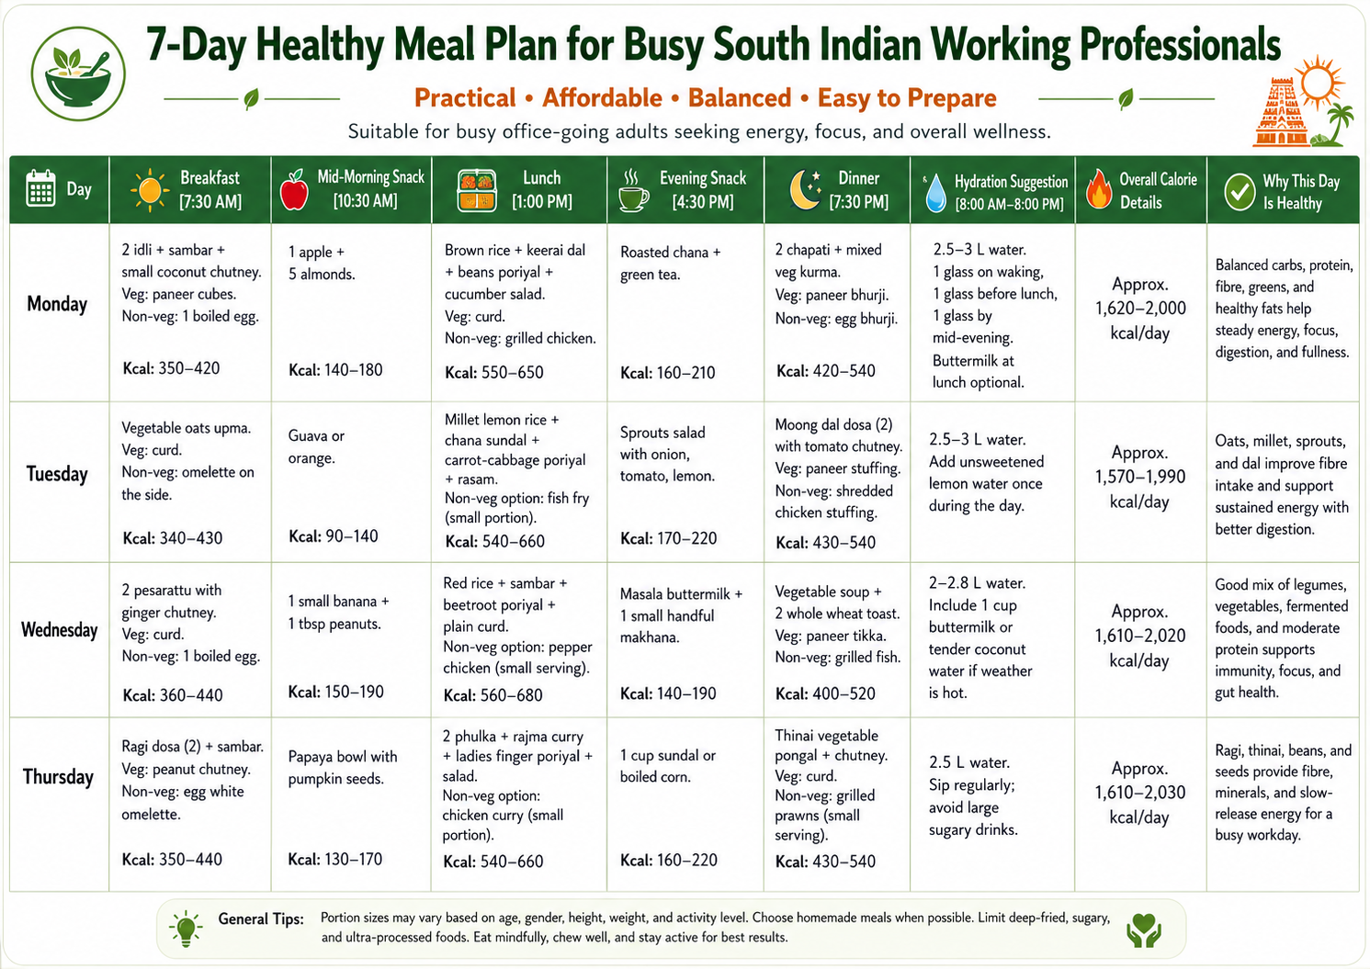
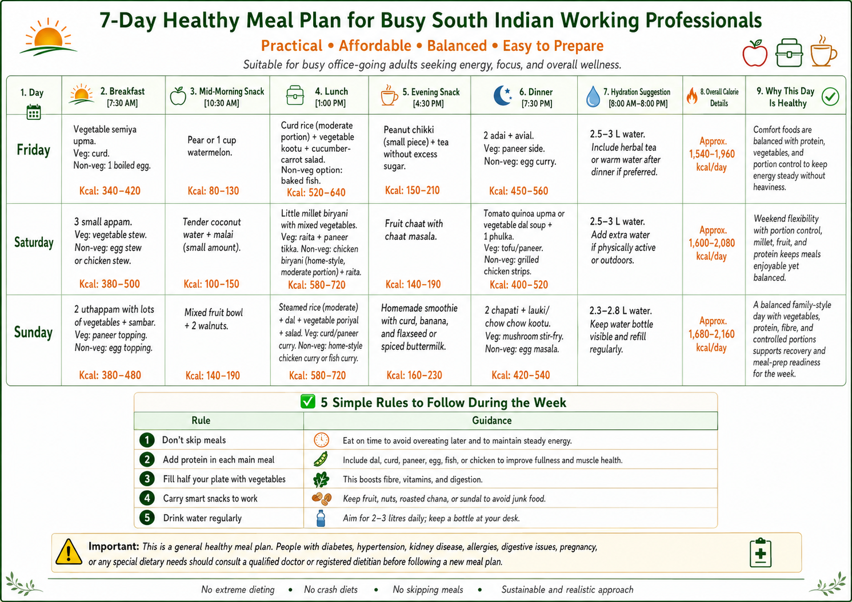

Simple Rules to Follow During the Week
Rule | Practical Action
1. Do not skip breakfast | Keep idli/dosa batter, oats, boiled eggs, curd, or fruit ready.
2. Add protein to every main meal | Use dal, chana, sprouts, curd, paneer, tofu, egg, fish, or chicken.
3. Control oil and sugar | Use less ghee, reduce fried snacks, and cut sugar in tea/coffee.
4. Meal prep twice a week | Chop vegetables, cook dal, boil eggs, and prepare batter in advance.
5. Choose smart snacks | Pick sundal, roasted chana, fruits, nuts, sprouts, buttermilk, or boiled corn.

Important Health Note
This is a general healthy meal plan, not a medical diet. People with diabetes, high blood pressure, kidney disease, food allergies, pregnancy-related needs, digestive issues, or special dietary requirements should consult a qualified doctor or registered dietitian before following any meal plan.

